BỘ GIÁO DỤC VÀ ĐÀO TẠO
ĐỀ THI ĐÁNH GIÁ NĂNG LỰC TIẾNG ANH - ĐỀ MINH HỌA SỐ 1 KỸ NĂNG ĐÁNH GIÁ: NÓI
(Dành cho học sinh lớp 12 đã hoàn thành Chương trình tiếng Anh thí điểm cấp Trung học Phổ thông)

SECTION 4: SPEAKING

Time: Approximately 13 minutes

Part 1: Interview

Questions for Candidate A
- What is your name?
- How often do traffic jams happen in your hometown?
- What means of transport do people in your hometown like?
- What means of private transport do you like?
- What are some advantages and disadvantages with this means of transport?

Questions for Candidate B
- What is your name?
- How often do you use public means of transport?
- What public means of transport do you like?
- Should people be encouraged to use bicycle?
- What are some advantages and disadvantages of using bicycles?

Part 2: Monologue/Picture description

Candidate A will be given the following picture:
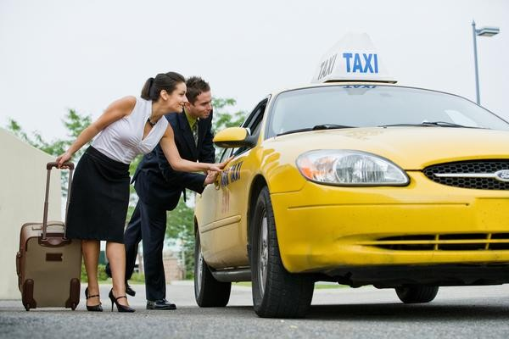

Question for candidate A: "This photograph shows a means of transport. Please tell us what you can see in the photograph."

Candidate B will be given the following picture:


Question for Candidate B: "This photograph shows a means of transport. Please tell us what you can see in the photograph."

Part 3: Paired discussion or further individual discussion

Option 1: Dialogue/Paired discussion

Intro text: In Part 3, you will discuss a given topic together.

The interlocutor will ask the two candidates: Do you agree with the statement: “Bicycle riding is good for your health”? Support your agreement or disagreement with examples and reasons.

Let’s now start the discussion. Candidate A, could you start please? Could you start, Candidate B?

Option 2: Further individual discussion with the examiner

Intro text: In Part 3, you will answer further questions given by the interlocutor.

Questions for candidate A
- Should students who live near their school walk to school? Why or why not?
- What causes traffic jams in your hometown?
- What are some solutions to reduce traffic jams?

Questions for candidate B
- What are some public means of transport in your country?
- What are some advantages of using public means of transport?
- What are some disadvantages of using public means of transport?

