BỘ GIÁO DỤC VÀ ĐÀO TẠO
ĐỀ THI ĐÁNH GIÁ NĂNG LỰC TIẾNG ANH - ĐỀ MINH HỌA SỐ 2 KỸ NĂNG ĐÁNH GIÁ: NÓI
(Dành cho học sinh lớp 12 đã hoàn thành Chương trình tiếng Anh thí điểm cấp Trung học phổ thông)

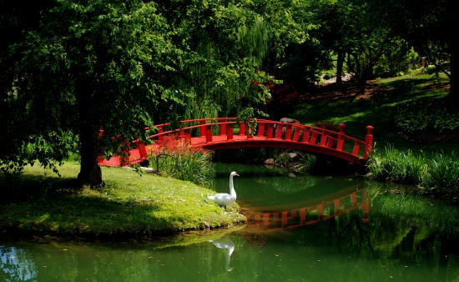
SECTION 4: SPEAKING
Time: Approximately 13 minutes

Part 1: Interview
Questions for Candidate A
- What is your name?
- Are you living in a house or a flat?
- How long have you lived in this house/flat?
- What do you like about living in this place?
- What don’t you like about living in this place?

Questions for Candidate B
- What is your name?
- Do you prefer to stay in a house or a flat?
- What is your favorite place in your house/flat?
- What are some advantages of having a house with a garden?
- What are some disadvantages of having a house with a garden?

Part 2: Monologue/Picture description
Candidate A will be given the following picture:

Question for candidate A: "This photograph shows part of a park or a botanicalgarden. Please tell us what you can see in the photograph."

Candidate B will be given the following picture:
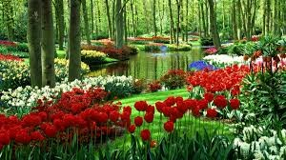

Question for Candidate B: "This photograph shows part of a park or a botanical garden. Please tell us what you can see in the photograph.”

Part 3: Dialogue/Paired discussion OR further individual discussion

Option 1: Dialogue/Paired discussion

Intro text: In part 3, you will discuss a given topic together.

The interlocutor will ask the two candidates: Do you agree with the statement: “Living in the city is better than living in the countryside”? Support your agreement or disagreement with examples and reasons.

Let’s now start the discussion. Candidate A, could you start please? Could you start, Candidate B?

Option 2: Further individual discussion with the examiner

Intro text: In part 3, you will answer further questions given by the interlocutor.

Questions for candidate A
- What do you think about gardening?

- Who usually does gardening?
- What are some advantages and disadvantages of doing gardening?

Questions for candidate B
- Why do some old people like to live in the countryside?
- Should villagers build modern houses in their area? Why or why not?
- Should people in the city spend their weekends in the countryside? Why or why not?

